Welcome to BUZZARDS class!
There is one class teacher in Buzzards.
Miss Trehane is the Class Teacher
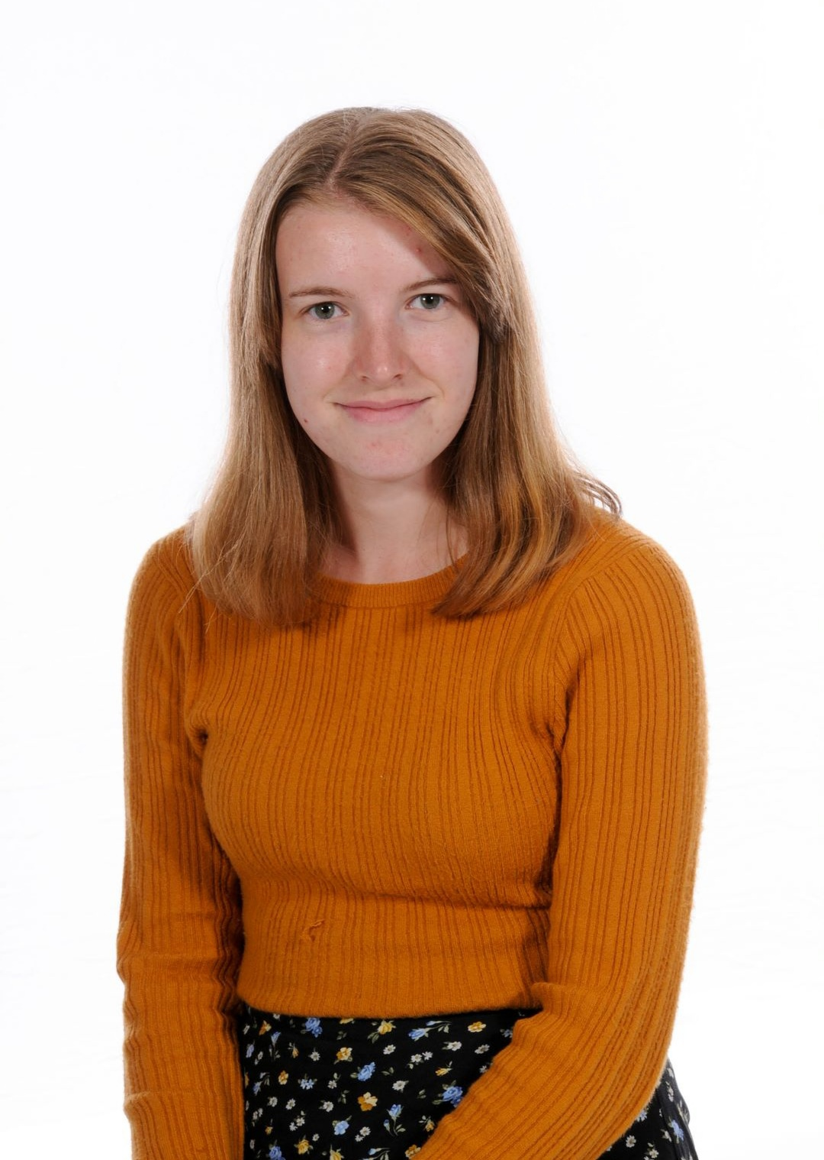

Mrs Black is our class teaching assistant. She is in school every morning and some after noons.
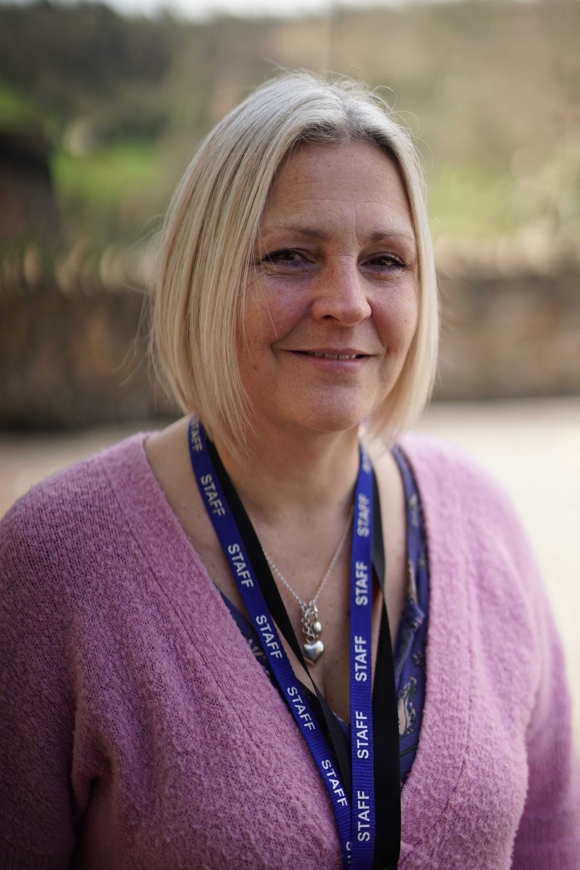

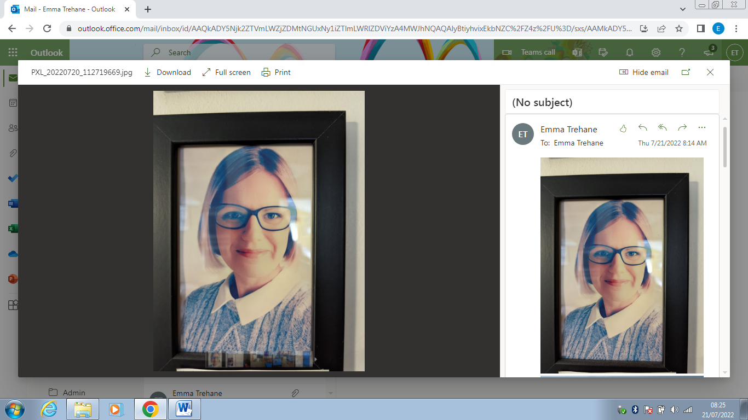
Mrs Hepper is our 1:1 teaching assistant. She is in most mornings and some afternoons

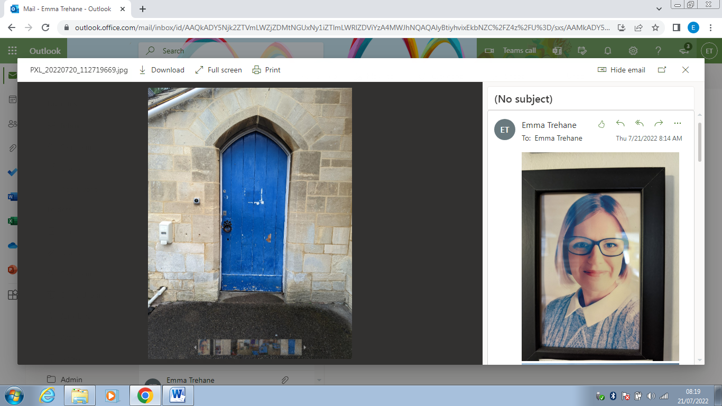
When you arrive at school you go round through the blue door.

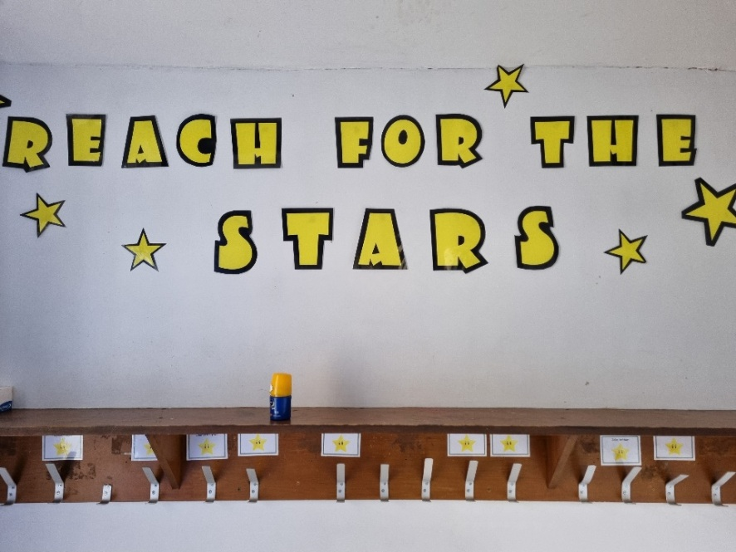
Here is the cloakroom. This is where you keep your coat, bag and lunch bag.

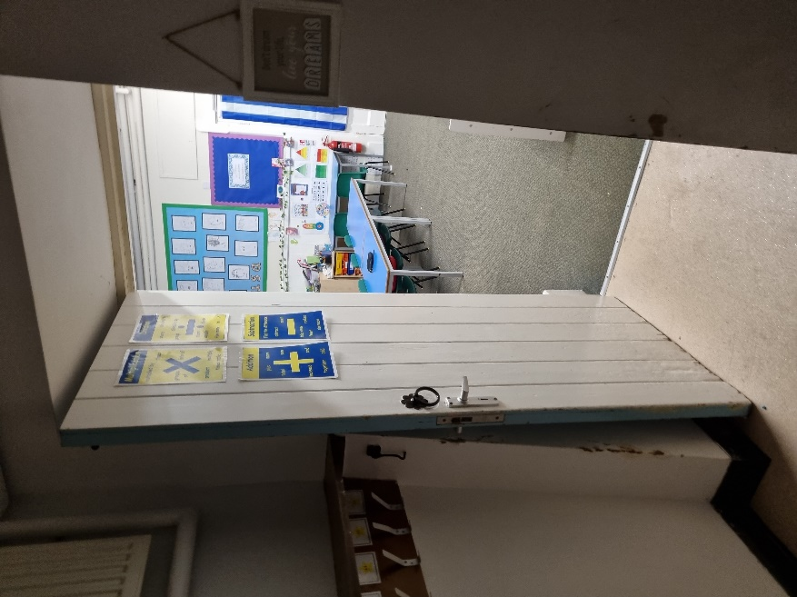
You go through the cloakroom to enter the classroom.

Here is Buzzards classroom. The tables may be laid out differently in September.

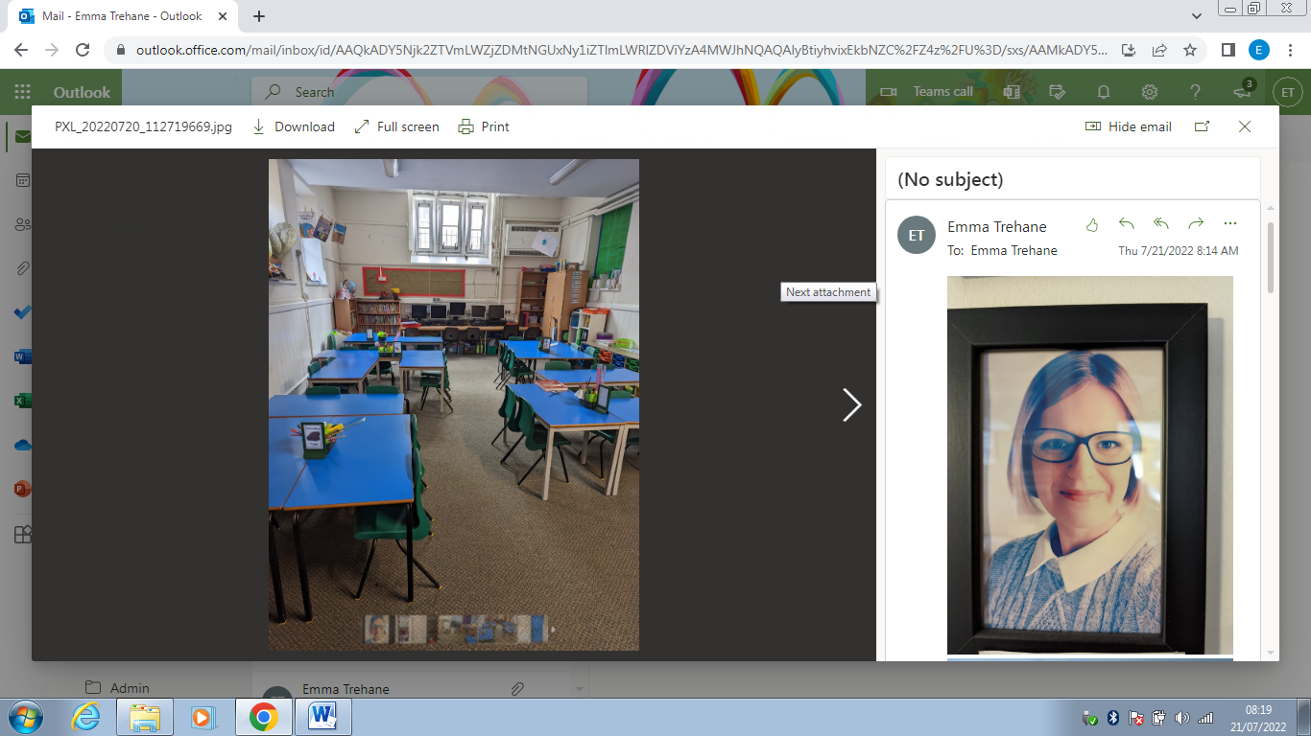
.

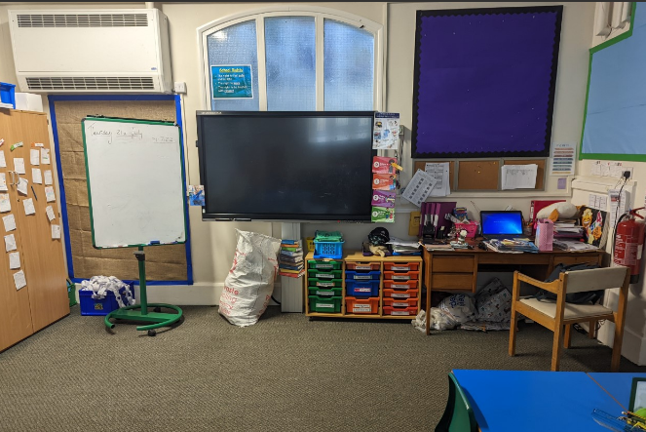

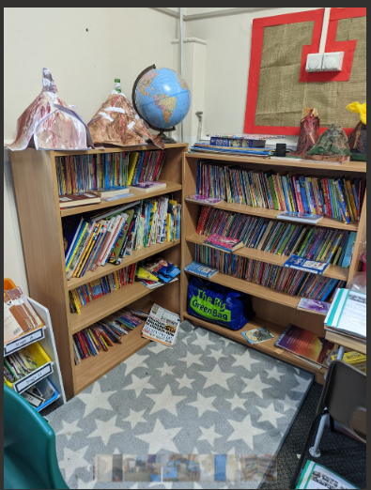
This is the reading corner area.

The reading stage books are next to the reading corner

We have a wet room to wash your hands. The bin is in the wet room.

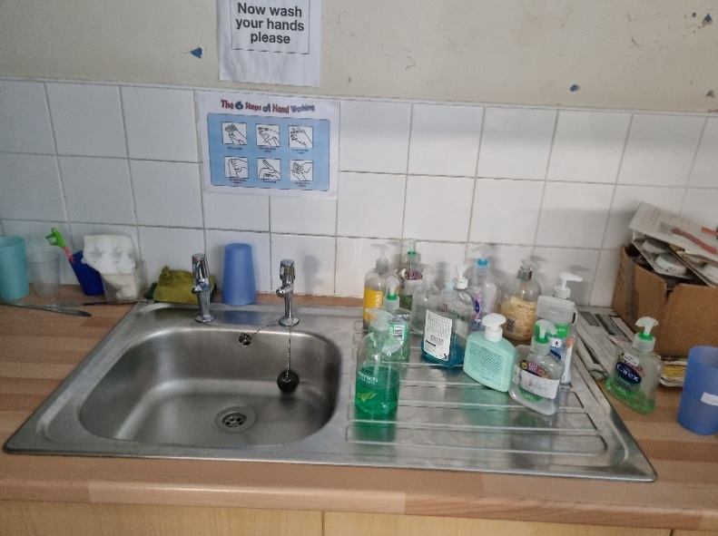
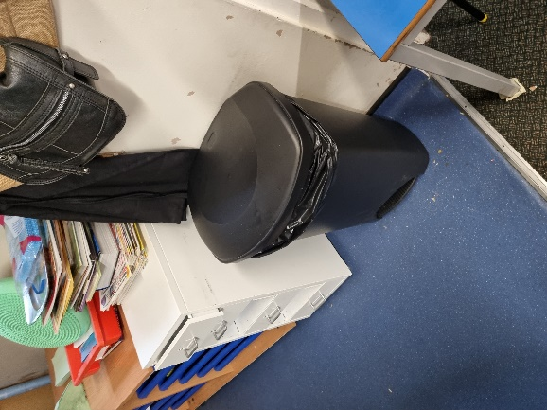

Exercise books are at the back of class.
Computers are at the back of the class.

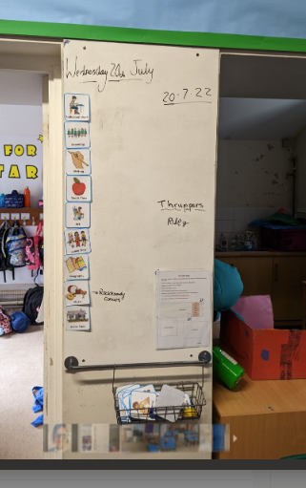

We will put the plan for the day on the main board in the classroom.

We are really looking forward to welcoming you to Buzzards class in September!

