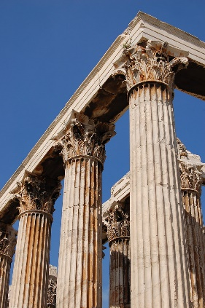
Welcome to Ancient Greece.

Our Buzzard’s Class Homework for Autumn 2025 is all about our Greek topic.
I’d like you to choose one of these activities to complete for your homework every fortnight. Choose your favourites and tick them off as you compete them.
Bring your creations into school to share on: Tuesday 7th October, Tuesday 21st October, Tuesday 11th November, Tuesday 25th November, Tuesday 9th December
Have fun, I can’t wait to see what you come up with!
Mrs Southgate
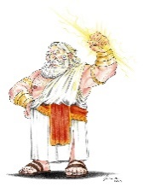
1. Ancient Greek Trading Cards
This Photo by Unknown Author is licensed under CC BY-NC-ND
Choose a creature or God from Ancient Greek mythology and create a trading card. This should include key facts, a description, and an illustration of the creature.

2. Greek City-State Map
Create a map of Ancient Greece, pinpointing major city-states like Athens and Sparta, as well as important geographical features. Your map can be 2D or 3D!
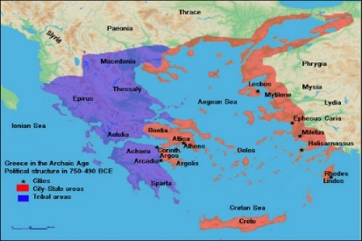

3. Mythology Puppet Show
Create puppets to act out a scene from a well-known Ancient Greek myth. You can write a short script and perform it for the class.

4 Greek Food
Research traditional Greek recipes and have a go at making a Greek dish at home! You could write up the recipe for us to try too!
5. Speak Greek
Learn some simple Greek phrases, such as Hello, Goodbye, Please and Thank You., Why not make a mini Greek-English dictionary? You could even try to teach us all a little!

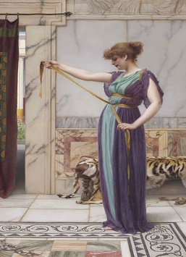
6. Ancient Greek Costume
This Photo by Unknown Author is licensed under CC BY-SA
Find out about the clothes Ancient Greeks wore. You could draw and label a picture showing a typical Ancient Greek outfit. If you make an outfit bring some photographs or wear the costume to school!

7. Greek History News Report
Write or record a newspaper report about a significant event in Ancient Greece, such as the founding of Athens or the Battle of Marathon, including quotes and illustrations.

8. Create a Labyrinth
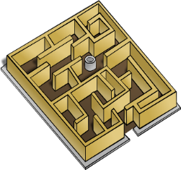
Design your own Labyrinth. It could be made of straws, string or wood.

9. Ancient Greece Quiz Game
Create a quiz game based on Ancient Greece, include questions about gods, goddesses, myths and Greek geography for classmates to play.

10. A Greek Diary
Write a diary extract from the viewpoint of a person living in Ancient Greece. Try to write about your feelings and experiences in daily life.

11. Come to Greece!
Design a travel brochure about Ancient Greece. Where would you travel to? Where would you stay? What could you do while you were there? Who would you recommend visits? Use pictures with lots of facts and information.

12. Create a Greek temple, like the Parthenon, using a range of construction materials.


