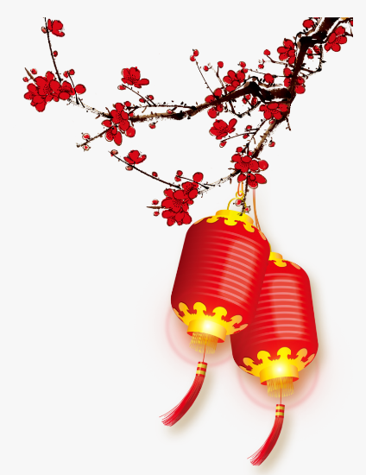
China!
Eagles Topic Homework Tasks
Below are a range of tasks related to our topic that cover lots of different areas of the curriculum.

We would like you to complete one activity of your choice every fortnight and then bring your finished task into school. We will share and display your work in the classroom.

We will be expecting a task in on the following dates:

Tuesday 9th May
Tuesday 23rd May
Tuesday 13th June
Tuesday 27th June

We look forward to seeing your work!

- Find a recipe for Ginger Millet Porridge and have a go at making it, or find out about other foods that the Shang people would have eaten. Send in some photos or share the recipe.

- Find out about the discoveries at Huanbei and write a news report. You could start your research here: https://www.independent.co.uk/life-style/history/human-sacrifices-discovered-at-torched-shang-dynasty-city-huanbei-1975492.html

- Find a piece of Shang craftsmanship that you like, such as a bronze or a piece of Jade. The British Museum website is a good place to start. Do some research on the internet. When and where was the item found? What was it used for? Sketch or make a model of it.

- Find out more about Chinese pictograms and calligraphy. Create an information poster.

- Design and make a Shang Dynasty boardgame. It could be a timeline game, a city building game, a conquering lands game, a trading game – use ideas from board games that you know to help you.

- Find out about a myth or legend of a Chinese dragon and retell the story.

- Design a symmetrical pattern that might have appeared on a piece of Shang artwork. Can you create something with one line of symmetry? Two? Four?

- There was one very special animal that people farmed in the Shang period. It wasn't a mammal, it wasn't a bird, it was an insect! It is an insect called Bombyx mori and it makes a very special fabric that the Chinese are still famous for. Find out about the silk worm and write a non-chronological report, including the life cycle.

- Make a model of a Chinese dragon.

- Watch an Expedia travel guide to China on YouTube (with an adult) and create your own travel brochure.
Useful websites:
Shang Dynasty - BBC Bitesize:
https://www.bbc.co.uk/bitesize/topics/z39j2hv
Shang Dynasty - the School Run:
https://www.theschoolrun.com/homework-help/shang-dynasty
Oak Academy lessons from lockdown:
https://classroom.thenational.academy/units/the-shang-dynasty-75f2
Ancient China for Kids:
https://china.mrdonn.org/shang&chou.html
Twinkl Shang Dynasty Homework Help:
https://www.twinkl.co.uk/blog/homework-help-the-shang-dynasty

