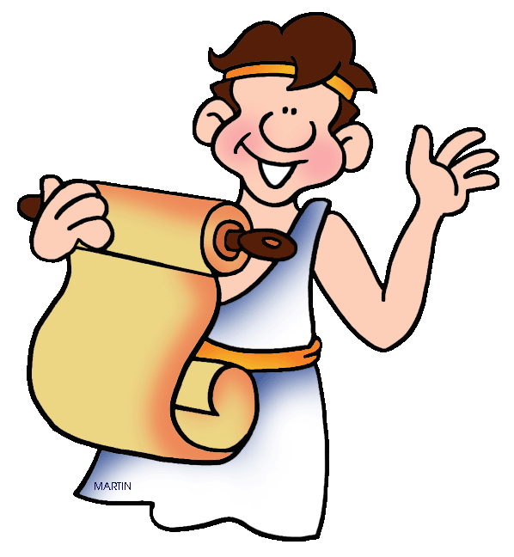
The Romans Are Coming!
Eagles Topic Homework Tasks
Below are a range of tasks related to our topic that cover lots of different areas of the curriculum.

We would like you to complete one activity of your choice every fortnight and then bring your finished task into school. We will share and display your work in the classroom.

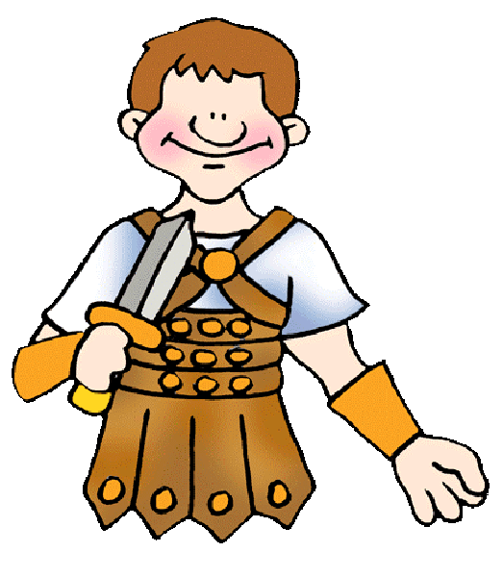
We will be expecting a task in on the following dates:

Monday 26th September
Monday 10th October
Monday 31st October
Monday 14th November
Monday 28th November
Monday 12th December

We look forward to seeing your work!

Tasks
- Find out some information about modern day Rome. In what ways had the city changed since its early days? Which aspects have stayed the same?
Create a travel leaflet about modern day Rome.

- The Roman Army was very skilled and organised. They also looked impressive. What sort of designs did soldiers have on their shields?
Design and make your own Roman shield.
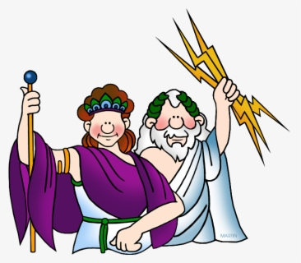
- Find out about Hadrian’s Wall, including why it was built and the role it played in the Roman invasion.
Create a poster to show what you have learnt.

- Read some Roman myths.
Create your own comic strip to retell your favourite.

- Find out about aqueducts. What were they used for and how did the Romans build them? Make a model aqueduct.

- Find out about Roman villas.
Draw a diagram of a villa, labelling the different rooms and features. You could even make a model villa.

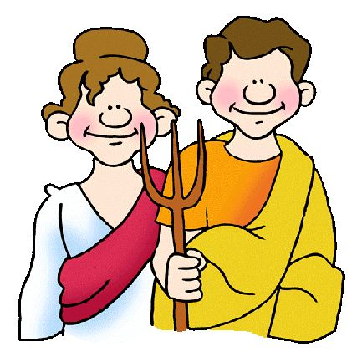
- What was it like to be a child in Roman times?
Research and make your own information book including facts about daily life, toys, games and education.

- What did the Romans do for entertainment?
Design a poster advertising the best Roman entertainment in town!

- Have a day out with your family and find out about the Romans in our local area. You could visit the amphitheatre in Cirencester (this is free to visit). You could also visit the Coronium Museum in Cirencester or the Museum of Gloucester to see Roman ruins, artefacts and mosaics.

- Make a map of the UK marking on the main Roman settlements and Roman roads that still exist today.

- Find out about what happened at Pompeii.
Write an eyewitness account of the events.

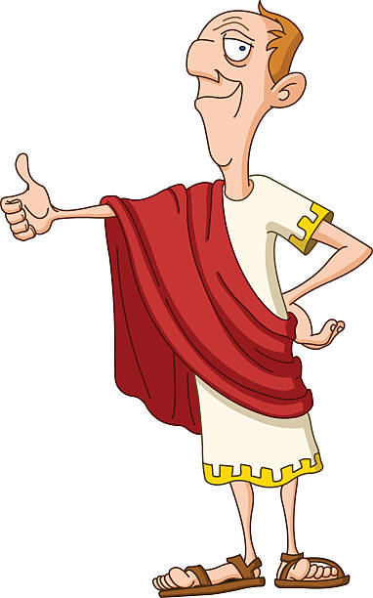
- Create a timeline of Roman emperors. Find out about some of the horrible things they did!

- Romans used metals in coins (eg silver, bronze), armour and weapons (eg bronze, iron), jewellery (eg silver, gold), cooking utensils (eg pewter) and water pipes (lead).
Create a table showing what different metals are used for and why they are used in those ways.

- Romans made sundials and water clocks to tell the time. Find out more about how these work and make your own model of a sundial or a water clock. Can you test it to see if it is an accurate time measurer?

