Homework
Children will have a weekly piece of maths that will be given out on a Friday, to be completed and returned the following Thursday.

We have created a list of other homework activities that are cross curricular for your child to choose from. We would like at least one activity to be completed and returned every two weeks. Details will follow on a separate Homework sheet.

We would appreciate your support in helping your child to complete their homework. Some homework activities can be completed by your child independently and some are intended to be shared with someone else at home. Homework is consolidation and reinforcement for your child’s learning and also gives you an opportunity to see what your child is doing in class.

Spelling Shed – at least twice a week for 10-15 minutes

Children already have logins for this website: https://play.edshed.com/en-gb/login. A new spelling list will be set for your child to work on each week, linked to the spellings they are working on at school. Please support your children in learning these spellings; we are able to check their progress with these online.

TT rock stars- year 4
In the summer term, the Year 4 children will be taking a new National assessment called the Multiplication Tables Check. Children will be tested using an on-screen check (on a computer or a tablet), where they will have to answer multiplication questions against the clock. A good website to practice this skill is TT rock stars; children already have logins for this website: https://play.ttrockstars.com/. We will log on each week to check children’s progress.

Reading
Please continue to read fiction and non-fiction with your child and record comments in their reading record. All reading is positive, including newspapers, magazines and online information. Children should record at least three comments in their reading records a week. Children will also read in school independently, as part of group and in whole class reading sessions therefore they should have their reading book and reading record in school daily.

We would appreciate your support in helping your child to complete these homework tasks.

Thrupp Primary School

Information for Parents
Autumn 2022:

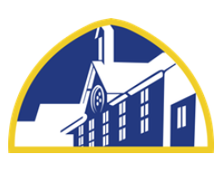
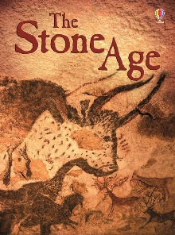
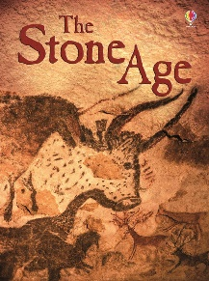
TOPIC:
The Stone Age

Buzzard Class

Class Teacher: Miss Trehane
Teaching assistant: Mrs Black
1:1 Teaching assistant: Mrs Hepper

In computing, the children get the opportunity to use the school laptops regularly. We will be using Purple Mash and learning about coding and how to be safe on the internet.

Our geography will look at countries around the world, continents and cities in the UK! This includes looking at the different climates in the world.

Science fun this term includes looking at rocks and soils, and investigating fossils. Then we will also look at light and how light travels, reflections and shadows.
________________________________________________________

Be The Best’ Fridays
For Term 1, Y3 will be led by Mr Bird on a Friday afternoon ‘Be The Best’ slot, and Y4 will be led by Mrs Westward.

Lots of exciting opportunities will be happening this term, so please do keep up to date with the school newsletters, our class webpage and letters to follow! Our class webpage is updated with information and photographs of what we have been doing.

Please make an appointment to speak to me or arrange a meeting if you have any questions about your child or what we are doing in class. Our class email will be checked weekly: buzzards@thrupp.gloucs.sch.uk. For anything urgent, please contact the school office or leave a message with the teacher on duty at the gate in the morning and we will get back to you as soon as possible.
________________________________________________

Organisation
PE will be held every Thursday and Friday, for the first term. On these days, please send your child to school wearing their PE kit – long hair should be tied back, jewellery out / off, and we expect all of the children to have a water bottle with them.

Please can the children wear PE kits on ONLY these days and their usual uniform on the other days of the week please

Just a little reminder that toys and teddies should not be brought into school. I don’t want your child to damage them or lose them!

Welcome to a new school year! I hope everyone had an amazing summer!

We have a slight change of staffing this year, we are very happy to have Mrs. Parker-Stanley as a new addition to our team, she will teach Buzzards class for most of Thursday. We are also very fortunate to have our teaching assistants Mrs. Black, Mrs. Westward and Mrs. Hepper who will be supporting children in the class over the course of the week. I am so excited to be teaching your child, here are some of the amazing things we are going to be looking at this term!

Our topic this term is The Stone Age! We will become explorers and archeologists to discover the history behind the Stone Age. This includes looking at artefacts, cave painting and the lives of people in the Stone Age.

Within English, we will be looking at fiction and non-fictions texts that link to our topic. We will be producing diary entries, recounts and stories. Spellings will be taught in year groups once a week and will continue to be linked to spelling shed (please see homework section). In whole class reading sessions, we will be reading the text A pebble in my Pocket: A History of Our Earth by Meredith Hooper and Chris Coady- if you are able to supply a copy of this text for your child, it would be really beneficial for them to have their own copy.

Our Maths focuses this term will be looking at number and place value, as the children learn to work with higher numbers. The focus will then be on addition, subtraction, division and multiplication for both year 3 and 4.
By the end of the year:

The Year 3s are expected to know the 3x, x 4 and x 8 times tables

The Year 4s are expected to know the 6x, x 7, x 9, x 11 and x 12 times tables
___________________________________________________________

In history we will explore the timeline of the Stone Age and compare and contrast the lives of people during this time. We will also become archeologists and look at artefacts from this time period.

For our art lesson we will be exploring cave art and creating our own early to modern pieces. During DT, we will be looking at cave monsters and creating our very own ones.

