Thrupp Primary School
Playground Development Report July 2018

The report has been produced to guide the Thrupp school playground development. This can be used by the school, governors, PTA and other organisations involved in the project.

The school is committing to improve and enrich the play provision to meet the requirements of the children’s health and wellbeing.

Background

We are a small village school with a thriving community. We work as a co-operative team: pupils, staff, parents and governors, to create a sense of ownership and a feeling of pride in our school. Working together to make Thrupp School, and every member of its community, be ‘the best they can be’ is central to our vision.

Thrupp School has 136 pupils (58.1% Boys, 41.9% girls, 13.2% Pupil Premium, 15.4% Special Educational Needs) on roll from the age of 4-11, plus 20 children in the on-site nursery which has children from the age of 2 years and 9months. The school is growing in numbers with the PAN (Published Admission Number) recently increased by county from 17 to 20.

In 2017, the old infant buildings were knocked down and replaced by a new classroom block on the original infant playground (See plan Appendix A)

The site plan attached (Appendix A) shows the area which is now available to be developed for play opportunities. This is a unique opportunity to improve the environment and facilities at the school to better meet the children’s needs for play.

This development is taking place at an important time when there are barriers to children’s play due to traffic, fear of stranger danger and risk aversion which are having an adverse impact upon children’s health and well being. Further primary school children are increasing obese and are plan will encourage them to adopt a healthier lifestyle at an early age.

This development will address this and improve children’s personal and social development and educational attainment.

It will also contribute to the school’s other plans highlighted on the School Improvement plan including the Eco Green Flag Award, Outdoor Learning Provision and Sports Development (School Improvement Plan link: https://thrupp.sharepoint.com/:w:/g/EZS7n9tQhV1Epp_qaUCdFs4B5d3VW9bE8u_wFjU-M6bTpw)

Thrupp School offers a wide variety of extra-curricular activities across a broad spectrum of interests throughout the year. The range of clubs which change termly, include: Art, Athletics, Chess, Choir, Country Dancing, Drama, Eco, Film, Hockey, Infantastic, Junior Journalists, Netball and Tag Rugby.

This outdoor development will help to extend the breadth and range of outdoor learning and activities that can be provided at the school including the re-introduction of Forest School.

Thrupp school has an energetic PTA with ambitious plans for activities at their school including Fetes, Bonfire Night celebrations, Social Evenings, Treasure hunts and much more. The development of the school site will also allow for other local community groups to use/hire the facilities and increase social capital and raise more funds for the school too.

The Steering Group

A steering group was convened by the Head Teacher to take this project forward and produce a strategic plan.

The group is comprised of the Head Teacher, teaching staff, governors, PTA representatives and an advisor.

The steering group consulted the school staff, governors, PTA and received their resounding support.

The group has undertaken a literature review of children’s needs for play and is applying national best practise and the national design principles for children’s play (http://playengland.org.uk/media/70684/design-for-play.pdf ). This enabled us to develop our blue print for the future.

The national review told us that children are increasingly obese and that there is a direct correlation between the amount of TV they watch and their waist measurements.

The importance of play for children’s development

The school has a key role in addressing the importance of play in children’s development by embedding an active healthy life style for children.

The national design principles (see above link) for creating inspiring play spaces to excite and challenge children suggest that successful play spaces:
- Are bespoke,
- Are well located
- Make use of natural elements,
- Provide a wide range of play experiences
- Are accessible to both disabled and non-disabled
- Meets community need
- Allows children of different ages to play together and
- Builds opportunities for children to experience risk and benefit.
The principles create a compelling argument for natural play landscapes containing natural materials such as logs, boulders, sand and open areas of grass to encourage children to explore the natural environment and increase sustainability.

The design principles also provides a typology of the play types all children need to develop. These are as follows:
- Communication play
- Creative play
- Deep play
- Dramatic play
- Exploratory play
- Fantasy play
- Imaginative play
- Locomotive play
- Mastery play.

Methodology

The steering group resolved that children’s involvement in the design of the site would be central to the approach that we take. Research shows that when children are involved in the design of a play area it is more likely to meet their needs, they are more likely to use it and they will want to look after it and treat it with respect.

That we would carry out an audit of the features that we have and identify the ones missing. Conduct a survey of children’s satisfaction to bench mark and determine what they want to keep and want more of and involve them in design activities to find out the features that they want/ need in the future.

Audit of Play (Appendix B)

Thrupp school is set in a countryside location with views across the valley from all areas of the site. There is a large open grass playing field already in use, as well as two tarmacked flat play areas and an Early Years Outdoor play area. There is also a large area of land surrounded by trees and shrubs which is undeveloped and set on a slope to the back of the school site. This is an exciting opportunity to develop and improve the play opportunities in all of these areas.

The steering group, staff and Premises committee carried out an audit of the grounds by applying the play principles to identify the things we have and the things we need.

The audit showed the following:

Things we have:
- A large, flat and fenced grassed sports field with fabulous views across the valley
- 2 large, level tarmacked play spaces with new markings for netball, football, track, various games etc and can also also used for wheeled toys, bikes etc too
- A grass bank and paved semi-circle and seating area which is surrounded by trees and valley views used for playtimes and Forest School, Outdoor Learning
- Lots of different areas for play
- A Pond which will be covered soon and has been assigned to a class to maintain
- Areas designated for planting and gardening and different classes are now responsible for these areas
- Most spaces can be used by children of varying ages
- There is access to the natural environment in most spaces due to the school’s location and fantastic views

Things needed:

- Several areas around the grounds need tidying
- Several areas ‘wasted’ need clearing, developing. Less than half the space available is well maintained or actually usable in its current state – an exciting blank canvas!
- Very few areas are accessible to all/ inclusive.
- Only a few spaces have good accessibility to toilets
- There are no spaces with differing levels/ heights – most surfaces on one level
- There are very few covered/ sheltered areas
- Not many areas encourage imaginary play or stimulate the senses

Satisfaction Survey (Appendix C)

A survey of children’s play satisfaction was carried out using Play England Satisfaction Indicators to determine the things that the children want to keep and want more of. It gives us a bench mark of how the children feel about play at the school before the project begins

The survey told us that the 3 most popular types of play by our children are: Being Active, Hanging out with their friends and Being Adventurous.

Most children were satisfied with the playground as it is but the majority (2/3) of children said that there isn’t enough choice of activities. They suggested a variety of things to improve the area with Climbing, Tunnels, Dens/Hideouts/Structures, Drawing/Art, Water and Nature/Gardening being some of the main suggestions.

Involvement in design

Children were actively involved in the design because they know best what will meet their needs. This was carried out in small interest groups, classes, year groups and in whole class assemblies. Their ideas were collected through discussions, questionnaires, drawing and painting pictures and making models.

We collated the findings (see below) and mapped the children’s needs against the features we have and identified the priorities and gaps.

Red: We do not have Amber: In the process of being created Green: Already have

Common themes from the children’s designs:
- Climbing
  - Climbing frames were rarely explicitly mentioned, but very often drawn.
  - Treehouses/ climbing structures eg Castles, Pirate ships regularly mentioned
  - Some specifically looking for a challenge (eg climbing walls)
- Platforms - Specifically stages, for music/drama/performance in general
- Shelters - Castles, houses, dens
- Tunnels - Most specifically underground – huge number of requests for this - Often drawn if not written request

- “Zones”
  - Separate areas for different activities were a very common theme
  - Secret places – for privacy or adventure
  - Themes zones – friendship areas, moods
  - Cosy, comfy zones mentioned

- Swings - Lots of mentions - Requests for different levels of challenge – eg “BIG swing”

- Zip lines - frequently mentioned and drawn

  - Gymnastics equipment – Mats, Beams / bars, climbing equipment
- Seating - Benches, chairs, Places to eat

- Standard sports - Especially football – almost universal, Also netball/basketball and quite a few mentions of golf (crazy golf?)

- Slides - requests for different levels of challenge of slide

- Water - But mainly to be in it (swimming, diving) Swimming pools, Hot tubs, Slides, Some requests for drinking fountains (good idea!)

- Nature areas - Lots of mentions of ponds, Some gardening / vegetables

- Trampolines - Also bouncy castles - Very common

- Sand - Sand pits, Beaches, Long jump

- Hopscotch

- Computer areas – mostly games

- Mazes

- Pets/ animals

Conclusion:

Having considered the findings there are things that can be achieved on a short term, medium term and long term basis. Some of these can be carried out as part of the school curriculum or extra curricular activities and some by assisted partners, PTA and local businesses carried.

They are not mutually exclusive and these are summarised in the attached table (Appendix D).

The site has tremendous potential to support the children’s expressed needs and to meet the feasibility of the project. We recommend that a play environment designer is employed to incorporate the priorities into a scheme which will make best use of the school site and the resources available, with a cost-effective maintenance programme.

We have several areas for ball games and playground markings have already been arranged for the new tarmacked area for football, netball and basketball. Hopscotch already exists on the bottom playground and new markings including a track for vehicles will be added.

Classes have agreed areas to work on and take responsibility for in the school grounds including the pond and gardening/ vegetable plots. Parents have been invited in to help clear areas so that they can be used safely over the summer term.

The PTA have agreed in principle to help fund a new climbing structure/ platform.

The red areas have not been addressed and can be put forward when considering further playground design options.

For more information – photographs of childrens’ designs, newsletters, staff ideas and other supporting documents please follow the link below:

https://drive.google.com/drive/folders/1Rs9GCcyDHcajMv9MN02YBTULQpl_BZAB?usp=sharing

Appendix A – Site Plans
Buildings removed - site for new playground
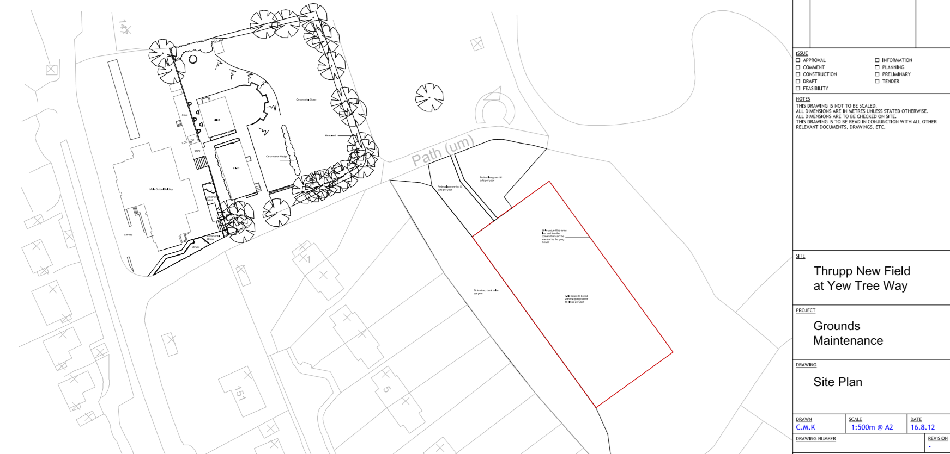
New Infant Block Location

School Playing Field

Area to be developed
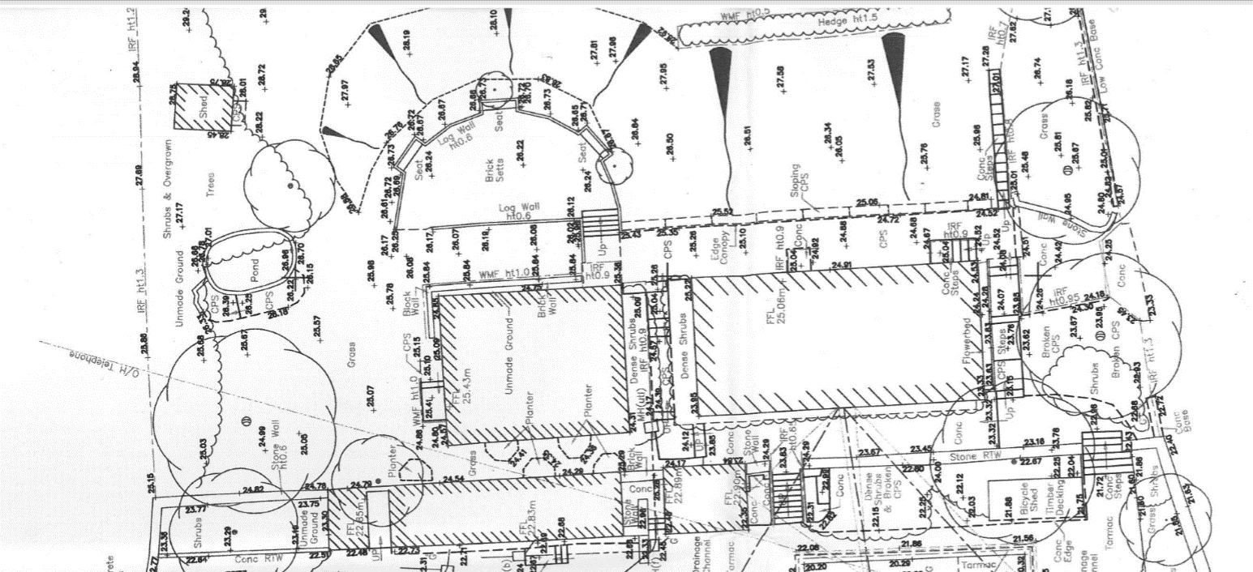

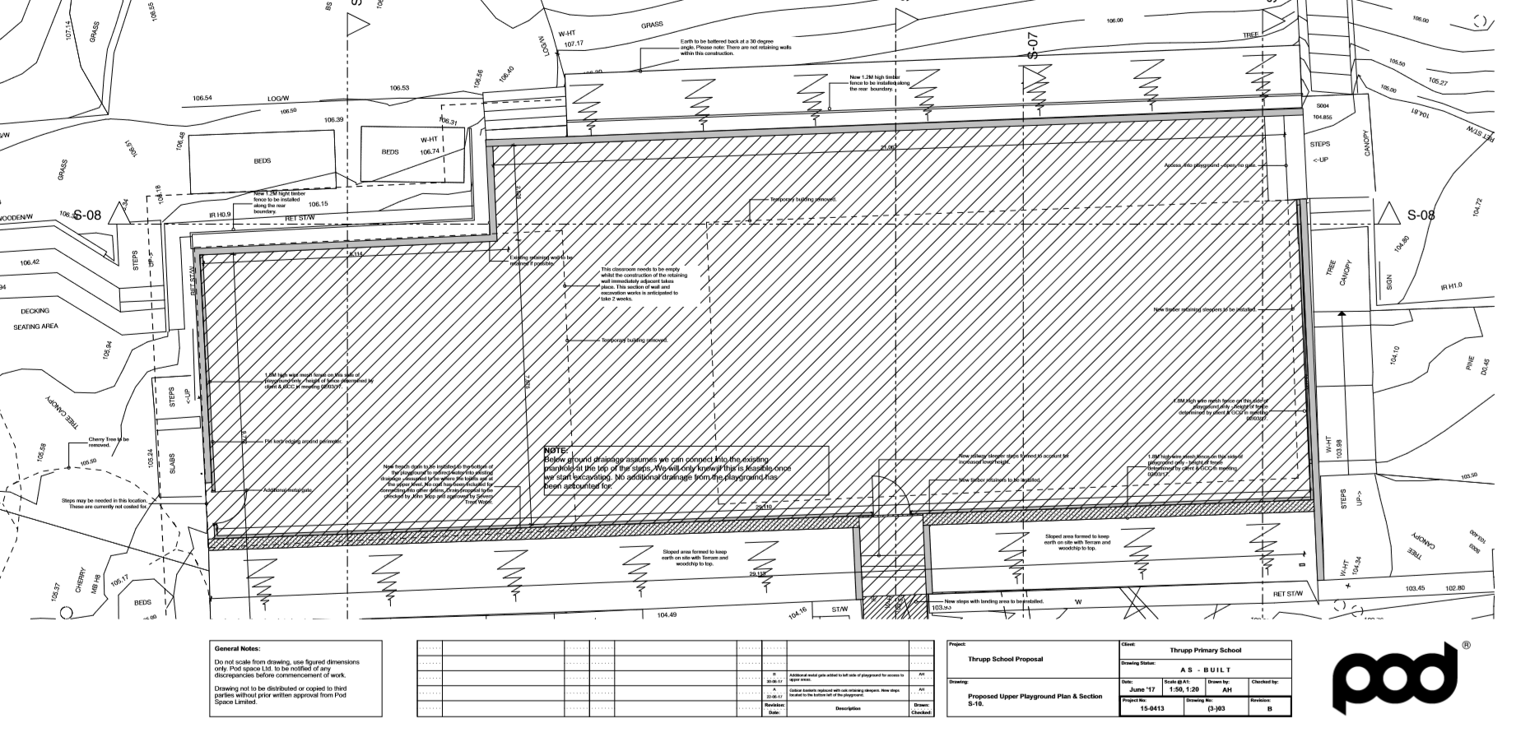
Appendix B Audit of Play
Audit of the school site to identify play features and facilities

There are approximately 10 areas around the school which are currently used, or could be used, for outdoor play A – F are shown on the plan and G-J are off the plan in other areas around the school site.

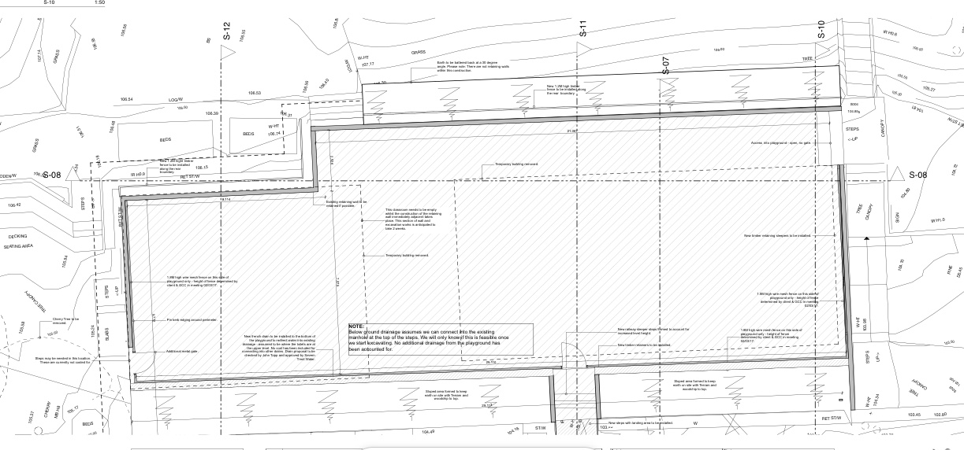
F

E C

D B A

A – The site of the previous Nursery and Kestrels’ classroom – this will be flattened and resurfaced and will be used for PE lessons/ ball games etc. Views across the valley.
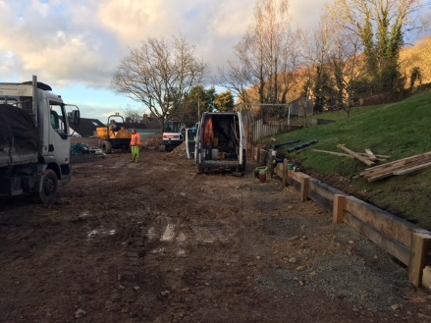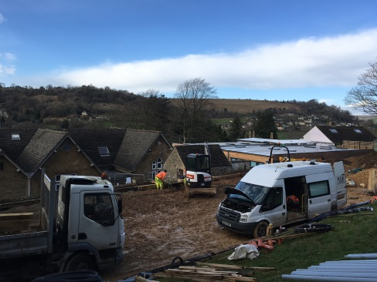
B – The site of the previous Hawks’ classroom – this will also be resurfaced – will probably be an extension of the main play area (A) or could be used for something else?
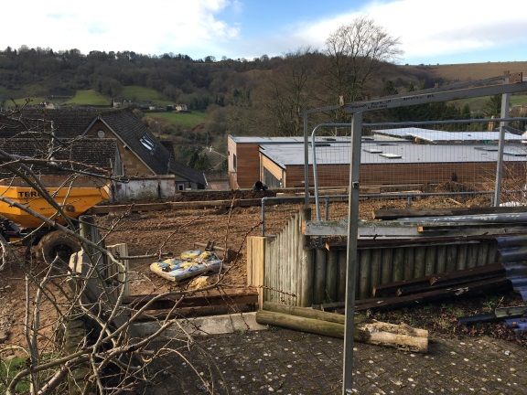

C- The old semi-circle area – used to an outside classroom – did have benches? Raised beds? Unsure of these will still be fit to use.
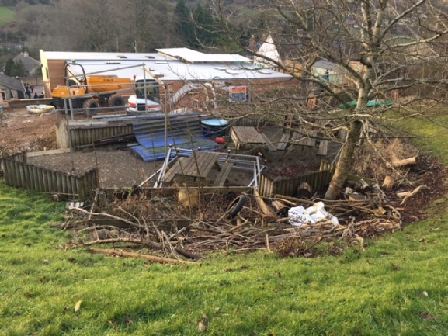
D – Terraced seating area and willow den (probably destroyed?), small grass area
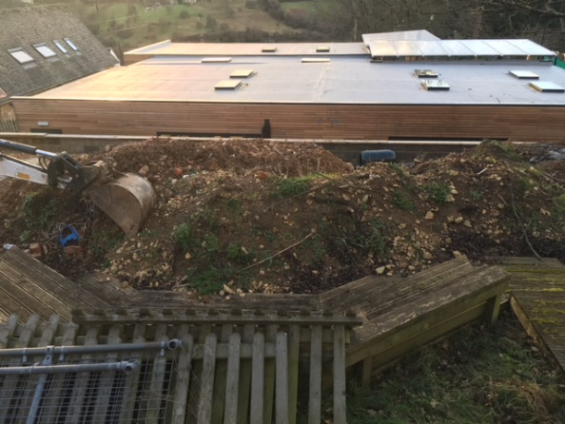
E – sloping grass bank, shed and overgrown pond, compost bins?
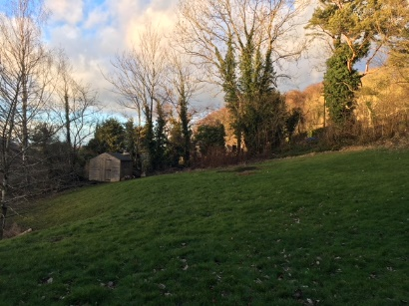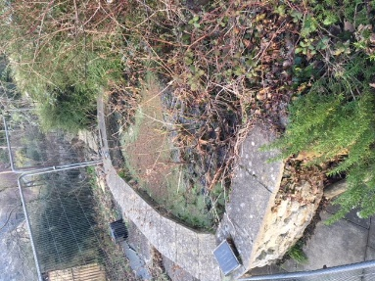
F – Large grass area, used for forest school, playtimes etc.
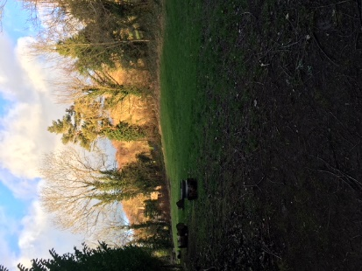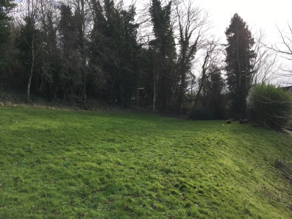

G - Off plan –New large grass field used for PE, sports activities and playtimes. Views across the valley.
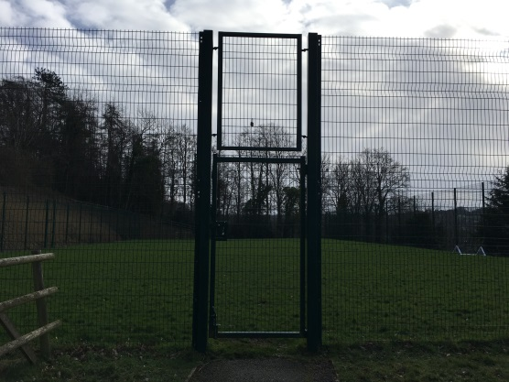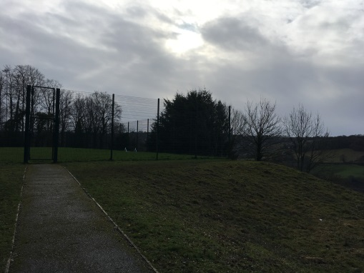
H – Off Plan – Bottom playground, shelter and benches one end, large flat tarmacked area at the other – currently used for PE and playtimes
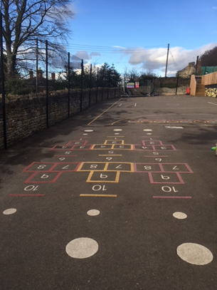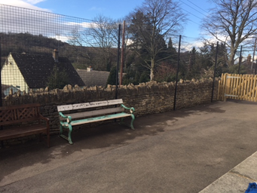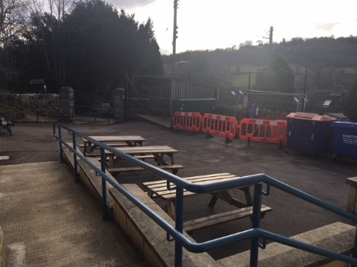
I – Off plan – small area outside new build next to Hawks – unused
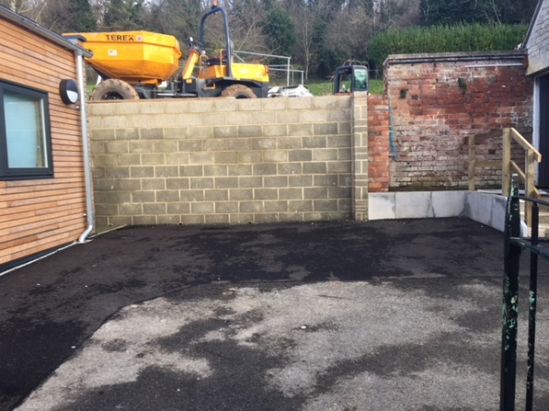
J –Off Plan - Purpose built, Early Years decking area attached to new building.
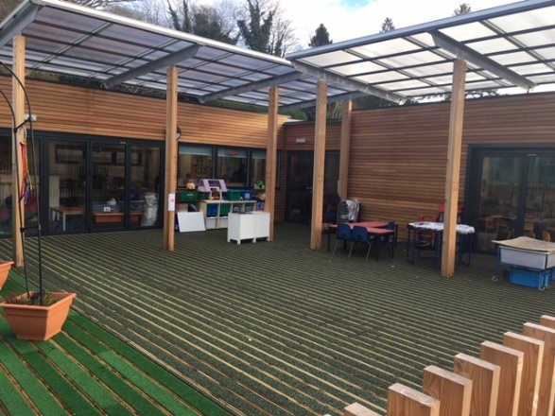
Site | A | B | C | D | E | F | G | H | I | J | Total for category /50
Accessibility / Inclusion | 1 | 1 | 0 | 0 | 0 | 1 | 1 | 4 | 4 | 5 | 17
Used by different aged children | 5 | - | 5 | 5 | 4 | 5 | 3 | 5 | - | 4 | 36
Movement (Space) | 5 | - | 3 | 3 | 3 | 4 | 5 | 5 | 1 | 3 | 32
Movement (Various levels/ heights) | 0 | 0 | 0 | 1 | 0 | 0 | 0 | 0 | 0 | 0 | 1
Encourages a range of play experiences | 2 | - | 2 | 3 | 2 | 3 | 2 | 3 | - | 4 | 21
Ball games | 5 | - | 1 | 1 | 0 | 3 | 5 | 4 | 0 | 1 | 20
Opportunities for risk taking and challenge | - | - | - | - | - | - | - | - | - | -
Makes use of natural elements | 3 | 3 | 3 | 3 | 3 | 4 | 3 | 1 | 1 | 3 | 27
Stimulate senses | - | - | 2 | 2 | 3 | 3 | 2 | 1 | - | 3 | 16
Places for children to sit | 0 | - | 4 | 5 | 0 | 1 | 0 | 3 | - | 3 | 16
Well maintained | - | - | 0 | 0 | 0 | 1 | 4 | 3 | - | 3 | 11
Usable as it is | 0 | 0 | 0 | 0 | 0 | 3 | 4 | 4 | 0 | 4 | 15
Toilet accessibility | 2 | 2 | 2 | 2 | 2 | 1 | 0 | 5 | 5 | 5 | 26
Cover/ Shelter | 0 | 0 | 0 | 1 | 0 | 1 | 0 | 2 | 0 | 3 | 7
Total for site /70 | 21 | 6 | 22 | 26 | 17 | 30 | 29 | 40 | 11 | 41

0 = None/ Poor 5 = Excellent/ Lots
Appendix C – Satisfaction Survey Results
Play Satisfaction Survey: RESULTS

- What I like to do...
- What I think about our playground as it is now...

3. What would make it better?
Featured Highly | A place to make things/draw/colour  Adventure Playground  Adventures  Bats and Balls  Climbing Frame  Climbing Frame  Dens  Drawing Area  Football Pitch  Garden (Plants/Flowers/Gardening)  Hang out area  Hopscotch  Monkey Bars  More Space  Nature Garden  Options  Place to sit (Benches/logs)  Roundabout  Skipping Ropes  Slide  Swings  Things to climb on (Climbing Wall/Trees)  Things to play on/with/equipment/toys/activities  Trampoline  Tunnels
Mentioned more than twice | A secret base/room/space  Bouncy Castle  Chalk Wall  Drinkable Water  Grass  Hide and Seek  Markings (Sports pitches)  Mediating Area/Yoga  Paddling Pool  Playhouse  Running track  Sandpit  Shade  Stepping Stones  Water Play  Water Slide  Waterfall/Stream  Wheeled toys (Bikes, Scooters, Skateboards)  Zip Wire
Mentioned | A ‘noise wall’  A higher fence for ball games  Alice in Wonderland Rabbit hole  Castle  Digger  Dinosaurs  Freedom to play what we want to play  Ice Cream  Not so many holes  Physical Stuff  Pillows  Rope Swing  See-saw  Skate Park  Wooden Ship  Yoga
- Is there enough choice in the playground...

- What would you like to see?
Featured Highly | Calm area/Active area  Climbing Frame  Climbing Wall  Den Building  Flowers  Football (Incl. Goals)  Football pitch  Grass  Markings  Monkey Bars  Monkey Bars  Nature  Nature Garden  Obstacle Course  Obstacle Course  Race Track  Skipping Ropes  Slide  Swing  Trails  Trampoline  Tree house  Underground tunnels  Waterslide
Mentioned more than twice | Basketball Hoops  Bridges  Castle  Equipment  Fairy lights  Maze  Reading area  Roundabout  Stepping Stones  Wheeled toys
Mentioned | A wooden Pirate Ship  Bouncy Balls  Death Slide  Gym  Kids and adults having fun  Shoot Target  Stage  Tents  Treasure Hunt

Appendix D – Action Plan Draft


